Fault Analysis for Traction systems in High-speed Trains

Pooja Singh, *Senior Member, IEEE*, Rajshree Patale

***Abstract*-** The safety of highway-rail crossings is a critical concern for both transportation systems and society. The failure of such systems may lead to severe risks of human lives, property, and transportation assets. Due to increased collisions at railway-road intersections, where road vehicles and trains collide. Due to these accidents are rising. To address these challenges, this paper proposes an effective approach utilizing statistical features and an improved Broad Learning System to enhance fault detection and preventive measures. The proposed method aims to deliver real-time cautionary signals and ensure safer operations in high-speed train systems.

*Index Terms*: Safety-critical systems, Fault detection diagnosis, Broad learning system, traction system, High-speed trains.

# **INTRODUCTION**

Railway accidents, including those at crossings and due to track misalignment or loss of wheel friction, are increasingly common despite advancements in safety technology. These accidents result in injuries, fatalities, and property damage. Ensuring the reliability of rail crossing safety systems and train tracks is crucial for preventing such incidents. Safety measures like warning bells, signaling systems, and control systems at crossings play a vital role in improving public safety and alerting drivers about approaching trains. These systems rely on both mechanical and electronic components to control traffic and notify drivers. Miscommunication, workload, and delays in information dissemination can lead to accidents. To address these issues, various AI methodologies have been proposed for fault diagnosis to enhance reliability. High-speed train systems rely on mechanical and electronic components, but issues like miscommunication and system malfunctions can still cause accidents. Traditional methods like fault trees are useful for root cause analysis but struggle with real-time detection and failure prediction. AI-based data-driven fault detection (FDD) techniques have emerged as alternatives, bypassing the need for complex mathematical models [1]. An additional study recommended deep neural networks for bearing system fault detection, and broad learning system (BLS)-based FDD hardware-in-the-loop simulations, minimizing the need for hardware adjustments and increasing validation efficiency. Experimental outcomes affirm the effectiveness and efficiency of the proposed FDD approach, indicating its practical applicability in real-world traction system diagnostics for high-speed trains. A different research indicated a modified BLS to improve rapid FDD in high-speed trains. Their advanced approach uses a dual-layer BLS structure, integrating output probabilities and statistical data features to enhance accuracy without sacrificing efficiency [2] [3-4]

Section II presents related work that discusses the findings of existing research papers that are based on Fault Detection and Diagnosis. Section III presents preliminary part and foundations used in our approach. Section IV contains the proposed methodology of statistical features and improved Broad learning system for traction software to detect and diagnose fault used in high-speed trains Section V presents the proposed framework of our approach on implementation of FDD using statistic feature and improved BLS for traction machine in high-speed trains.

# **related work**

D. Feng et al. [5] propose using AI techniques, like classification methods, for fault diagnosis in highway rail crossings, aiming to enhance safety through an advanced camera system. This system uses image processing and the YOLO tiny model to detect vehicles, pedestrians, and other elements in real-time with 89% recall, while ensuring data privacy when sending alerts.

This study [6] addresses trajectory tracking in high-speed trains (HSTs) using a distributed learning control approach within a multi-agent system (MAS) framework. It introduces a novel distinction between soft (information exchange) and hard (physical coupler) connections between carriages, enabling a more practical multipoint-mass dynamics model. By incorporating safety constraints, such as relative displacement and speed limits, and employing a barrier composite energy function (BCEF), the work ensures safe and precise tracking.

This work [7] explores reliability analysis methods for safety-critical systems (SCSs) in nuclear power plants (NPPs), particularly comparing traditional Fault Tree Analysis (FTA) with dynamic approaches like Time Series Markov Chains and Dynamic Flow graph Methodology (DFM). It highlights the limitations of FTA in modeling dynamic system interactions and non-binary logic, proposing DFM for assessing the Passive Residual Heat Removal System (PRHRS) in Pressurized Heavy Water Reactors (PHWRs) during station blackout scenarios.

This study [8] examines the reliability of Emergency Diesel Generators (EDGs) in Nuclear Power Plants (NPPs), emphasizing their role in ensuring safe reactor shutdown during power loss. It highlights limitations of traditional Fault Tree Analysis (FTA) in capturing system dynamics and introduces Bayesian Networks (BN) and Dynamic Bayesian Networks (DBN) as effective tools for probabilistic reliability analysis. The proposed framework integrates FTA and DBN to model and predict system failures over time.

This study [9] focuses on evaluating the overall reliability of the Traction Power Supply System (TPSS) in high-speed railways (HSR) by considering the impact of relay protection. Using Failure Mode and Effect Analysis (FMEA) and Fault Tree Models (FTMs), the study analyzes primary and secondary equipment, their coupling relationships, and relay protection logic. Monte Carlo simulations are employed to calculate comprehensive reliability indexes.

This study by Cheng et al [10] explores low-frequency oscillations in Train-Traction Power Supply Systems (TPSS) using a Single Input Single Output (SISO) voltage loop model. The research provides an analytical approach to identifying and mitigating oscillation issues in TPSS, contributing to the stability and reliability of railway electrification systems. The findings are validated through simulations and practical case studies, offering insights into optimizing TPSS performance.

Wang et al. [11] proposed a parallel monitoring approach for next-generation train control systems in their study. The research focuses on enhancing real-time monitoring and control by leveraging advanced technologies, improving the efficiency and reliability of train operations.

# iii. **PRELIMINARY Concepts**

Gear

Drive

Observation point 1

Intermediate

DC

Link

Traction

Inverter

Traction transformer

Pulse

Rectifier

Observation point 4

**Figure 1 .Traction Control System**

In a typical train traction system, [Fig.1.] embedded controllers manage motor speed and torque to ensure proper traction.[12] The system starts with alternating current (AC) voltage delivered to a traction transformer, which converts it to a single-phase AC voltage. This voltage is rectified to direct current (DC) and stabilized by a DC link. An inverter then generates three-phase AC to power the traction motor. For high-speed trains like the CRH2A, the traction system [Fig.2.] consists of four key components: a transformer, converter (rectifier, DC link, and inverter), motor, and traction control units (TCU). The system draws power from overhead lines (AC or DC), converts it through rectifiers and inverters, and controls speed using sinusoidal pulse-width modulation (SPWM). The asynchronous or synchronous traction motors convert electrical energy into mechanical torque. Regenerative braking may also be included to return energy to the power supply or onboard storage.

Transformer

Rectifier

DC Link

Inverter

Traction Motor

Traction Control Unit

**Figure 2. Circuit topology of Traction Control System**

Ref: Yin, J., He, Z., Liu, L. *et al.* Research on fault tracing method of traction drive control system. *J. Eng. Appl. Sci.* **70**, 143 (2023). <https://doi.org/10.1186/s44147-023-00313-6>.

1. **Fault Diagnosis**

Fault diagnosis [13-14] is a critical process to identify, isolate, and analyse system faults, ensuring reliability, safety, and efficiency in domains like high-speed trains, aviation, and industrial automation. Common approaches include model-based, signal-based, knowledge-based, hybrid, and active fault diagnosis [Fig3]:

1. Model-Based Diagnosis: Utilizes a system model detailing variable interrelations to monitor and analyze real-time processes.
2. Signal-Based Diagnosis: Compares real-time system signals with predefined healthy signal patterns, analysed via time, frequency, or time-frequency domains.
3. Knowledge-Based Diagnosis: Leverages historical data to infer system dependencies and validate real-time features using AI techniques.
4. Hybrid Diagnosis: Combines multiple methods to enhance coverage and reliability.
5. Active Diagnosis: Uses specifically designed test signals to distinguish between normal and faulty states more effectively.

Fault diagnosis methods are further divided into hardwareredundancy-based and analytical redundancy-based techniques:

* Hardware Redundancy: [Fig.4] employs redundant components like sensors, controllers, and diagnostic modules. Key mechanisms include passive redundancy (voting mechanisms), active redundancy (switching logic), and hybrid models.
* Analytical Redundancy: [Fig.5.] Detects faults through mathematical models and algorithms rather than additional hardware. Techniques involve system modelling (using equations, state-space models, or transfer functions), residual generation (differences between measured and predicted outputs), and residual evaluation to identify faults.

**Figure 3. Fault Diagnosis Technique**

**Hardware Redundancy:**

System under Monitoring

Sensors

Redundant Sensors

Detection Logic

False Alarm

Input

Output

**Figure 4. Hardware Redundancy Model**

**Analytical Redundancy:**

System under monitoring

Sensors

System Model

Detection Logic

False Alarm

Input

Output

**Figure 5. Analytical Redundancy Model**

1. **Artificial Neural Networks**

Artificial Neural Networks (ANNs) [15-16] extract insights from data to model system behavior without relying on mathematical models. During the training phase, ANNs process data to uncover statistical patterns, enabling real-time classification of system operations. Inspired by the human nervous system, ANNs act as estimators to analyze dynamic systems, relying on two critical factors: architecture and learning techniques.

### ANN Architecture: consist of interconnected layers [Fig.6]:

1. **Input Layer**: Receives raw data.
2. **Hidden Layers**: Transform data to extract features.
3. **Output Layer**: Provides predictions.

Neurons in each layer connect to all neurons in the previous layer, with weighted sums $\sum{Xi Wi}$ and activation functions (e.g., Sigmoid, ReLU, Tanh) enabling non-linear transformations. Data flows unidirectional in the **feed-forward Multi-Layer Perceptron (MLP)** architecture, which is chosen here for its simplicity, noise tolerance, and suitability for non-linear systems.

### Training and Parameter Selection

The **Levenberg-Marquardt algorithm** is used for training, balancing error minimization with computational efficiency. Parameters like the number of layers, nodes per layer, and activation functions are selected empirically to optimize accuracy and minimize errors.

### ANN as a Model-Free Method:

Unlike traditional models, ANNs [Fig7] statistically characterize processes. By adjusting weights and activation functions layer by layer, the MLP predicts outputs from inputs effectively. Proper architecture and training ensure robust performance in non-linear systems.

The concept can be understood through the following mathematical formulation  
Consider,

$$X_{1},X_{2},X_{3},…,X_{n}$$

As input signals and

$W_{k1 }, W_{k2} , W_{k3} , …., W_{kn}$

As the associated synaptic weights. The induced local output $U_{k}​$ is expressed as Y

$U_{k}=Wk_{1}X_{1}+Wk_{2}X_{2}+WK_{3}X_{3}+⋯+WK_{n}X_{n}.$

The output of the neuron, denoted by $Y_{k}$, is then given by:

$$Y_{k}=Φ\left(U_{k}+ B_{k}\right) \\ where Φ represents the activation function,$$

$and B_{k} refers to the bias input$.

The neuron's output is influenced by two factors: the bias $B_{k}$ ​ and the activation function ɸ. The bias ​ functions as an amplifier, where a value of

1+1+1

Results in positive amplification, and

−1-1−1

Leads to negative amplification.

On the other hand, the activation function ɸ determines the activation behavior of the neuron, thereby controlling its operational properties [17].

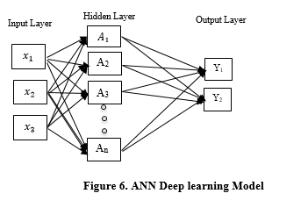

$$X_{1}$$

$$X_{2}$$

$$X_{3}$$

B

Inputs

Bias

$$\sum_{i=1}^{n}{w_{i}}x_{i}+b$$

Summation

$$B_{1}$$

$$B_{2}$$

$$B_{3}$$

Weights

Activation Function

Output

Y

**Figure 7. Mathematical Structure of ANN**

1. **Broad Learning System**

The BLS, initially introduced by Chen, demonstrates strong generalization capabilities and significant computational efficiency due to its architecture, which differs from traditional deep neural networks. The BLS network consists of two primary layers: the feature nodes layer and the enhancement nodes layer, arranged in a flat structure rather than a deep one In Broad learning system (BLS), input data X is mapped onto feature nodes via a nonlinear function as follows [18]:

$$Zi= ϕi (XWei + βei T), i= 1,…,n$$

Where $ϕi$ represents the activation function, n denotes the number of samples, and $Wei and βei ​$ are the randomly initialized weights and biases, respectively. All these feature nodes collectively form the feature nodes layer:

$$Zn= [Z_{1}, Z_{2} , … , Z_{n}]$$

The enhancement nodes are then mapped from the feature nodes using another function $ϕj$

$$Hj = ϕj (Z_{n} W_{hj} + B_{hj}T) j = 1 , …. M.$$

Where $Whj$ and $βhj$ are randomly generated weight and bias matrices. These enhancement nodes form the enhancement nodes layer:

$$H_{m} = [H_{1}, H_{2}, … , H_{m}]$$

The final output Y of BLS, which represents the classification probabilities, is computed by combining the feature and enhancement layers with a connecting weight matrix $Wm:$

$$Y= [Z_{n} ∣ H_{m} | W_{m}]$$

Here, $Wm$ is determined using ridge regression, which allows faster computation compared to the back propagation used in deep-learning models. This architecture is particularly advantageous in scenarios that require efficient and accurate diagnostics for high-speed train traction systems.

# **proposed Framework of our Approach**

This section outlines the framework of the Fault Detection and Diagnosis (FDD) approach, illustrated. The FDD structure has two main stages: an offline phase that applies statistical features and an enhanced Broad Learning System (BLS) model to both normal and fault data, followed by an online phase for real-time FDD in high-speed train traction systems [19] The methodology uses sensor data X gathered from high-speed train traction systems, which includes both normal datasets $Xn$ and fault-specific datasets $Xf$ where f denotes different fault types from $1 to F.$

The fault detection with statistical feature: before beginning fault detection, the dataset X (covering both normal data $Xn$ and fault data $Xf$ is normalized by centering it on the average to reduce any potential uncertainties. To generate distinguishable and representative features for detecting faults, Principal Component Analysis (PCA) is frequently employed for normal data $X$ n the mapped statistical feature $T^{2}$ is used to capture inherent properties. This feature is typically more sensitive to faults with large variances than the squared prediction error (SPE). The covariance matrix S of the normal data $X_{n}$ is calculated as follows:

$$S= 1/ N-1X_{n} X_{n}T$$

Next, Singular Value Decomposition (SVD) is performed on S, producing the load matrix P and eigenvalue matrix $Λ$ as:

$$S=PΛPT$$

Where P comprises principal component $Ppc$ and residual components $Pres​,$ with the eigenvalues $Λ$ split as:

$$Λpc = diag( λ_{1},…,λ_{1} ), Λres = diag( λ_{1}+1,…,λ_{m} )$$

The number of principal components l is chosen based on established guidelines. The statistical feature T2 is calculated as:

$$T_{2} = ∣∣ λ_{pc}-\frac{1}{2} P_{pc}T XT ||2 2$$

The criteria for fault detection in traction systems is as follows:

$If J ≤ Jth, T^{2} the system is normal.$

$If J > Jth, a fault is present.$

Here, J is the test statistic. And, 2​is the threshold, which is determined using the probability distribution of T2 and a tolerance level $α$ (usually set to 5%).

Fault Diagnosis Using an Enhanced BLS Model: Once a fault is detected, [20] it is essential to determine its type accurately and promptly. Unlike deep-learning-based models, BLS provides efficient fault classification with minimal training complexity. This method employs a dual BLS model setup, shown in figure 8, to enhance the inclusion of prior information and improve diagnostic accuracy. BLS accepts raw data as input feature represented as a vector X where n is the number of input features. The input undergoes feature mapping transformation to create a multiple features, mathematically feature mapping is often represented as Zi =, the output of the feature node is fed into the enhancement node, which introduce non-linearity and capture higher order representations of the data, the enhancement layer can be represented as $Hj = ɸ Zi Vj + cj$. The output layer aggregates the result from the feature mapping nodes and Enhancement nodes and computes the final prediction, as shown in figure 9. The final prediction is obtained by combining the contributions from feature mapping and enhancement nodes. So, this way in the absence of deep layers the broad architecture facilitates faster computation used here in place of deep-learning structures, reducing the computational load significantly. For fault data $Xf$ PCA is used to generate the fault-specific statistical feature f1 as follows:

$$F_{1} = T_{2} when J ≥ Jth, T_{2}.$$

This feature f1 serves as the input to the first BLS model (BLS1). The feature node $Z_{li}$ n BLS1 is defined by:

$$Z_{1i} = ϕ_{i} (f_{1} W_{ei} + β_{ei}T ) , i= 1 ,…, n$$

Where the subscript "1" indicates the first BLS model. These feature nodes in BLS1 create the feature node layer Z1n as:

The enhancement node layer $Hm$ is generated similarly, using m sets of enhancement nodes:

$$H_{1m} = [ H_{11}, H_{12}, …, H_{1m} ]$$

Thus, the output of the first BLS model is calculated as:

$$Y1 = [Z_{n1} ∣ H_{1m} ] W_{1m}$$

Where $W1m$ is obtained using rapid ridge regression!

To further improve diagnostic accuracy, a second BLS model (BLS2) is used, creating a two-stage learning structure. The input to BLS2 is defined $as f2 = (f1,Y1$) following a similar process, the feature nodes in BLS2 are:

$$Z_{2n} = [Z_{21}, Z_{22}, …,Z_{2n} ]$$

And the enhancement nodes layer $H_{2m }$ is generated accordingly:

$$H_{2m} = [H_{21}, H_{22}, …, H_{2n}]$$

The final output of the FDD system is:

$$Y_{2} = [Z_{2n} ∣ H_{2n} ] W_{2m}​$$

__________________________________________________

**Statistical feature and Improved BLS for traction system:**

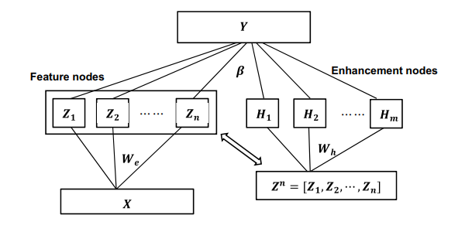

**Figure 8. Statistical Features of BLS**

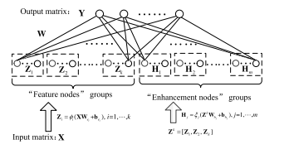

**Figure.9. Working of Broad Learning System**

Ref: Y. Zheng, B. Chen, S. Wang and W. Wang, "Broad Learning System Based on Maximum Correntropy Criterion," in IEEE Transactions on Neural Networks and Learning Systems, vol. 32, no. 7, pp. 3083-3097, July 2021, doi: 10.1109/TNNLS.2020.3009417.

_______________________________________________________________

Algorithm 1: Offline FDD Phase

$Input: Dataset X, including Xn​ (normal) and Xf (fault).$

$Output: Threshold Jth,T2 weight matrices W1m$

$and Wm-2 for both BLS models.$

$Preprocess Xn by centering on the mean$

$Perform SVD on Xn calculating Ppc and Λpc.$

$Determine T2 threshold Jth T2$

$Preprocess Xf as in Step 1.$

$Calculate f1 from Xf and obtain weight-$

$matrices of the BLS models.$

__________________________________________________

_______________________________________________________________

Algorithm 2: Online FDD Phase

$Input: Real-time dataset X.$

$Output: Fault type Y$

$Read and standardize real-time data X.$

$Calculate Ppc​ and Λpc​ for X and perform a test for fault presence.$

$If a fault is present, proceed to Step 4; otherwise,$

$return to Step 1.$

$Use the trained BLS model from the offline phase-$

$to diagnose the fault type.$

__________________________________________________

# **EXPERIMENTAL RESULTS**

**Fault Detection and Diagnosis (FDD) Testing:**

The proposed Fault Detection and Diagnosis (FDD) strategy was tested on two simulation platforms representing high-speed train traction systems:

1. **Software-Based Fault-Injection Simulation:** Developed using MATLAB/Simulink (Yang et al.), this platform enabled preliminary testing of the FDD approach under various fault scenarios. It provided a basis for parameter tuning and feasibility assessment before transitioning to hardware testing.
2. **Hardware-in-the-Loop Fault-Injection Simulation:** Built by China Railway Rolling Stock Corporation Zhuzhou Institute, this platform replicated real-world conditions, allowing for near-real testing of fault scenarios.

### Fault Types Tested:

Three fault scenarios were introduced to evaluate the FDD method:

* **Sensor Fault (U-Phase Current)**: Gain and offset faults affecting signal accuracy.
* **Traction Motor Fault**: Bar breakage and air gap eccentricity simulating mechanical issues.
* **Traction Converter Fault:** Open IGBT and sensor drift creating hybrid fault conditions.

### Fault Detection Results:

The performance of the statistical **T² feature** and **Squared Prediction Error (SPE)** was compared:

* **T² Feature**: Demonstrated higher sensitivity and stability across fault scenarios, detecting faults promptly and minimizing false alarms. T² visualizations (Fig. 10) showed thresholds clearly, with most values near the threshold. No significant faults were detected when observations remained below the threshold.
* **SPE Metric**: Detected faults with acceptable accuracy but was less sensitive, leading to false alarms in some scenarios. SPE visualizations indicated significant fluctuations, with some values crossing the threshold, suggesting potential faults.

**Frequency Distribution (Fig. 11):** Most T² values clustered below the threshold, indicating no major fault detections in the dataset.

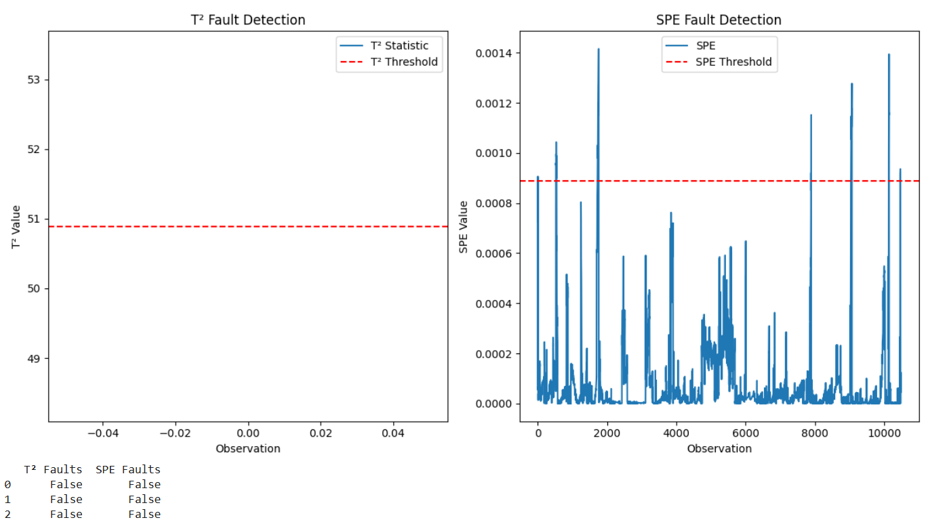

**Figure 10. T2 Statistics, SPE Metrics**

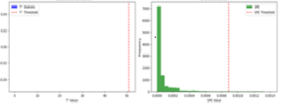

**Figure 11. Frequency Distribution of T2, SPE Values**

**Diagnostic Accuracy and Fault Detection:**

The performance of a traditional Broad Learning System (BLS) model and an improved BLS model was compared using confusion matrices (Fig. 12). These matrices provide:

1. **True Positives**: Correct predictions (diagonal cells).
2. **False Positives/Negatives**: Incorrect predictions (off-diagonal cells).

The **traditional BLS model** showed misclassifications, such as classifying Class 1 as Class 2. In contrast, the **improved BLS model** achieved perfect predictions with only diagonal values, indicating no errors.

The improved model achieved an average diagnostic accuracy of **99.8%,** outperforming the traditional model's **99.5%** across four conditions (three faults and one normal). This highlights the improved model's reliability under challenging real-world scenarios. [21-22]

### Hardware-in-the-Loop (HIL) Fault Detection

The HIL fault injection platform simulated sensor data faults using PCA. Key observations (Fig. 13):

* **X-Axis**: Time observations (0–500).
* **Y-Axis**: SPE values (residual error).
* **Fault Injection Point**: Marked by a vertical line at x=300x = 300.
* **SPE Threshold:** Red dashed line (99th percentile).

Low SPE values indicated normal operation, while peaks above the threshold signified faults after the injection point. Results confirmed that **T² outperformed SPE** for fault detection.

### Combined T² and SPE Analysis

Combining **T²** and **SPE** enhanced fault detection robustness (Fig. 14):

* **T² Peaks**: Captured major system deviations in the principal component space.
* **SPE Peaks**: Identified faults linked to residual variations unexplained by PCA trends.

### Fault Diagnosis System Performance

The fault diagnosis system was evaluated using two BLS models (Fig. 15):

* **Traditional BLS Model**: Simulated using an MLPClassifier with one hidden layer (50 neurons, 500 iterations). This model had more misclassifications, reflected in off-diagonal confusion matrix entries.
* **Improved BLS Model**: Used an enhanced MLPClassifier with a larger hidden layer (500 neurons, 1000 iterations), achieving near-perfect accuracy with values concentrated on the diagonal. The improved BLS model further increased diagnostic accuracy from **96.6%** (traditional) to **99.2%,** demonstrating its superior optimization and fault prediction capabilities [23-24].

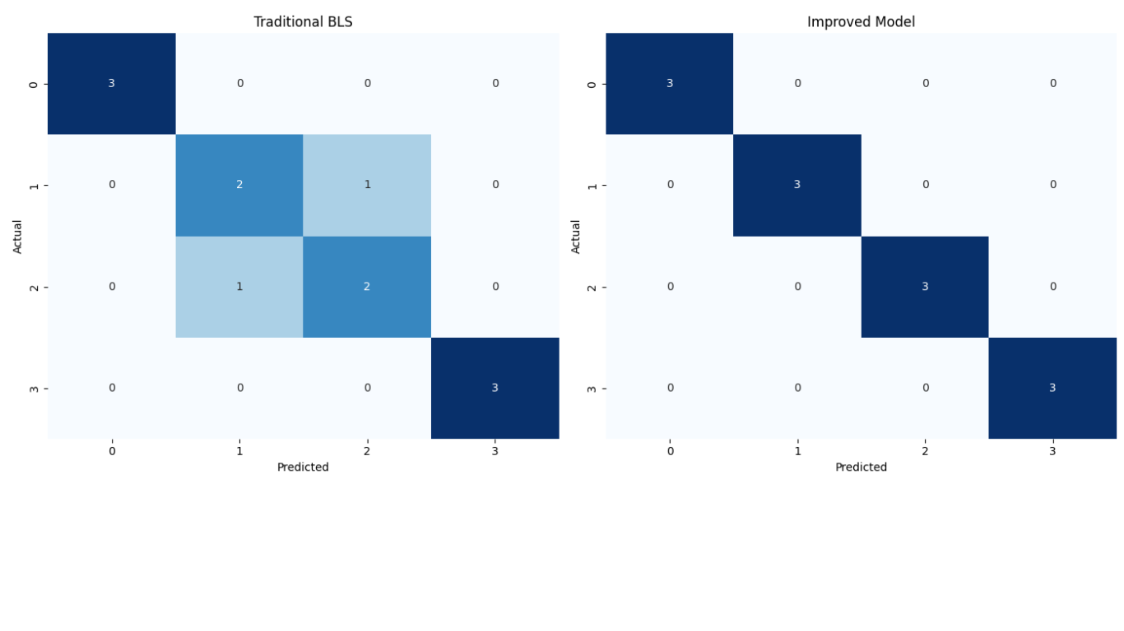

**Figure 12. Confusion Matrix for traditional BLS and Improved model**

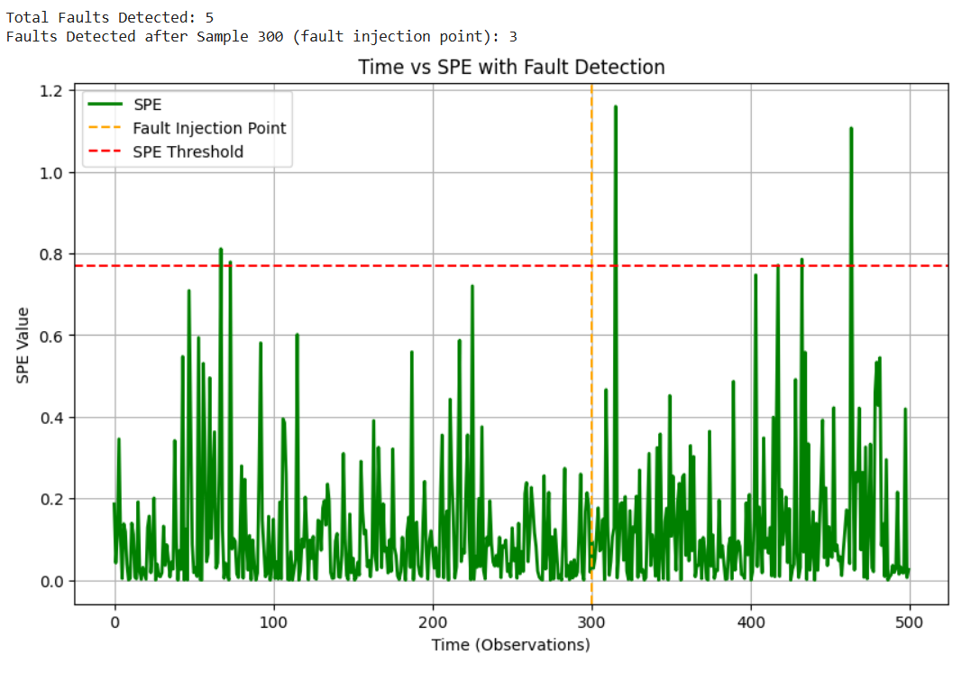

**Figure 13. HIL Fault injection and detection**

In comparative tests of four methods—SVM, deep forest, traditional BLS, and improved BLS—the **improved BLS** achieved the highest diagnostic accuracy: **99.79%** on the software platform and **99.17%** on the hardware platform. While slightly more computationally complex than traditional BLS, its superior accuracy makes it ideal for Fault Detection and Diagnosis (FDD) in traction systems, offering an effective balance between performance and usability.

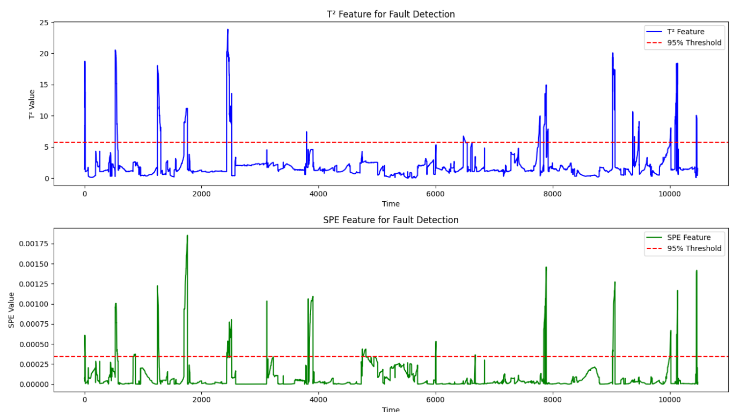

**Figure 14. Hotelling's T² statistic and Squared Prediction Error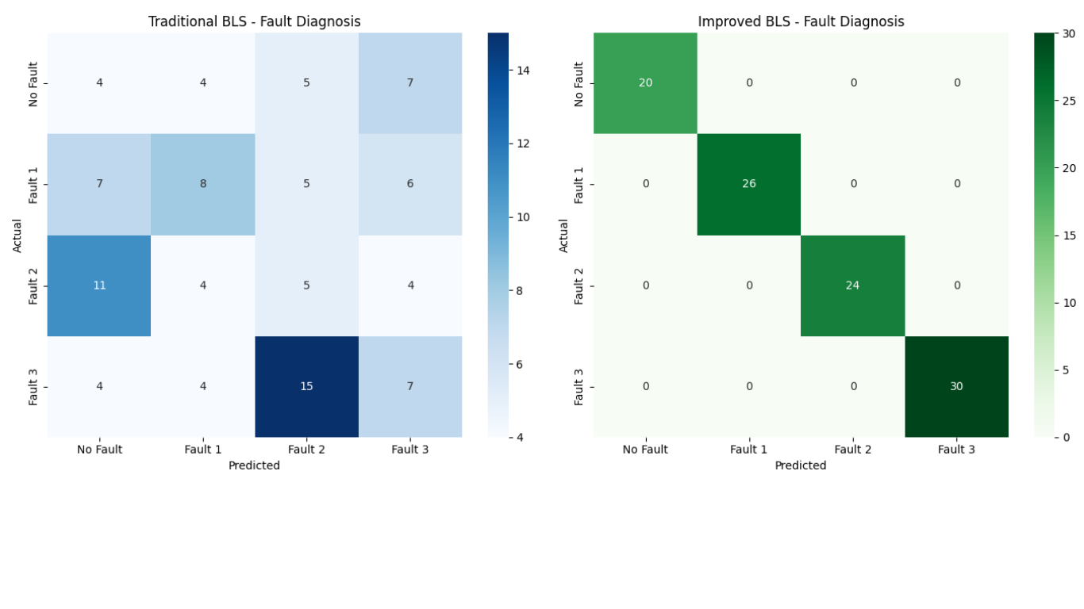Figure 15. Fault Diagnosis System using Traditional BLS and Improved BLS**

**Acknowledgment**

The authors would like to express their sincere gratitude to the Department of Science and Technology (DST), Science and Engineering Research Board (SERB), Government of India, for their financial support for this research under the “**Reliability Analysis of Safety Critical Systems using Artificial Intelligence,” SUR/2022/000347 dated 24-Nov-2023**. This work would not have been possible without their generous funding and continuous encouragement.

**References**

1. Zhang YJia RYang RSun H (2023) D S Net Expert Systems with Applications: An International Journal IEEE Transactions on Intelligent Transportation Systems, Volume 23, Issue 9 [1] 10.1016/j.eswa.2023.121020234, 30-Dec-2023.
2. V. Singhal et al., &quot; Artificial Intelligence Enabled Road Vehicle-Train Collision Risk Assessment Framework for Unmanned Railway Level Crossings,&quot; in IEEE Access, vol. 8, pp. 113790-113806, 2020.
3. S. Gao, Q. Song and D. Shen, &quot; Distributed Learning Control for High-Speed Trains Subject to Operation Safety Constraints, &quot; in IEEE Transactions on Cybernetics, vol. 54, no. 3, pp. 1794-1805, March 2024C.
4. C Cheng, W. Wang, H. Chen, B. Zhang, J. Shao and W. Teng, "Enhanced Fault Diagnosis Using Broad Learning for Traction Systems in High-Speed Trains," in *IEEE Transactions on Power Electronics*, vol. 36, no. 7, pp. 7461-7469, July 2021
5. D. Feng, S. Lin, Q. Yang, X. Lin, Z. He, and W. Li, “Reliability evaluation for traction power supply system of high-speed railway considering relay protection,” *IEEE Transactions on Transportation Electrification*, vol. 5, no. 1, pp. 285–298, Mar. 2019.
6. S. Gao, Q. Song and D. Shen, "Distributed Learning Control for High-Speed Trains Subject to Operation Safety Constraints," in *IEEE Transactions on Cybernetics*, vol. 54, no. 3, pp. 1794-1805, March 2024.
7. M. Tripathi, L. K. Singh, S. Singh and P. Singh, "A Comparative Study on Reliability Analysis Methods for Safety Critical Systems Using Petri-Nets and Dynamic Flowgraph Methodology: A Case Study of Nuclear Power Plant," in *IEEE Transactions on Reliability*, vol. 71, no. 2, pp. 564-578, June 2022.
8. Mohan Rao Mamdikar, Vinay Kumar, Pooja Singh, “Dynamic Reliability Analysis Framework using Fault Tree and Dynamic Bayesian Network: A Case Study of NPP,” Nuclear Engineering and Technology, Elsevier, Vol. 54(4), April 2022, pp. 1213-1220.
9. D. Feng, S. Lin, Q. Yang, X. Lin, Z. He, and W. Li, “Reliability evaluation for traction power supply system of high-speed railway considering relay protection,” IEEE Transactions on Transportation Electrification, vol. 5, no. 1, pp. 285–298, Mar. 2019.
10. S. Cheng, L. Ma, X. Ge, L. Peng and H. Liu, "Low-Frequency Oscillation Analysis in Train-Traction Power Supply System Using an SISO Voltage Loop Model," in *IEEE Transactions on Transportation Electrification*, vol. 8, no. 1, pp. 636-648, March 2022.
11. J. Wang, J. Wang, C. Roberts, and L. Chen, “Parallel monitoring for the next generation of train control systems,” in *IEEE Transactions on Intelligent Transportation Systems*, vol. 16, no. 1, pp. 330–338, Feb. 2015.
12. Z. Xu, W. Wang, and Y. Sun, “Performance degradation monitoring for onboard speed sensors of trains,” in *IEEE Transactions on Intelligent Transportation Systems*, vol. 13, no. 3, pp. 1287–1297, Sep. 2012.
13. H. Chen, B. Jiang and N. Lu, "A Newly Robust Fault Detection and Diagnosis Method for High-Speed Trains," in *IEEE Transactions on Intelligent Transportation Systems*, vol. 20, no. 6, pp. 2198-2208, June 2019.
14. D. Zhou and Y. Tang, “A model predictive control-based open-circuit fault diagnosis and tolerant scheme of three-phase AC-DC rectifiers,” IEEE J. Emerg. Sel. Topics Power Electron. vol. 7, no. 4, pp.2158–2169, Dec. 2019.
15. Sikora, P., Malina, L., Kiac, M., Martinasek, Z., Říha, K., Prinosil, J., Jirik, L., & Srivastava, G. (2020). Artificial Intelligence-Based Surveillance System for Railway Crossing Traffic. IEEE Sensors Journal, 21, 15515-15526. <https://doi.org/10.1109/jsen.2020.3031861>.
16. Z. Gao, C. Cecati and S. X. Ding, "A Survey of Fault Diagnosis and Fault-Tolerant Techniques—Part II: Fault Diagnosis with Knowledge-Based and Hybrid/Active Approaches," in IEEE Transactions on Industrial Electronics, vol. 62, no. 6, pp. 3768-3774, June 2015.
17. Singhal, V., Jain, S., Anand, D., Singh, A., Verma, S., Kavita, Rodrigues, J., Jhanjhi, N., Ghosh, U., Jo, O., & Iwendi, C. (2020). Artificial Intelligence Enabled Road Vehicle-Train Collision Risk Assessment Framework for Unmanned Railway Level Crossings. IEEE Access, 8, 113790-113806. <https://doi.org/10.1109/ACCESS.2020.3002416>
18. P. Singh and L. K. Singh, "Reliability and Safety Engineering for Safety Critical Systems: An Interview Study with Industry Practitioners," in *IEEE Transactions on Reliability*, vol. 70, no. 2, pp. 643-653, June 2021.
19. P. Singh and L. K. Singh, "State of Knowledge Correlation in Failure Analysis of Mechatronics Systems," in *IEEE Transactions on Reliability*, vol. 72, no. 1, pp. 240-247, March 2023.
20. P. Singh and L. K. Singh, "Reliability Measurement of Control and Instrumentation Systems of Nuclear Power Plants," in *IEEE Transactions on Reliability*, vol. 72, no. 2, pp. 727-736, June 2023.
21. P. Singh and L. K. Singh, "Modeling and Measuring Common Cause Failures in Measurement of Reliability of Nuclear Power Plant Systems," in *IEEE Transactions on Instrumentation and Measurement*, vol. 70, pp. 1-8, 2021, Art no. 3001608.
22. P. Singh and L. K. Singh, "Improved Measurement Accuracy in Critical Parameters of Safety-Critical Systems with Multisensor Data Fusion," in *IEEE Transactions on Instrumentation and Measurement*, vol. 70, pp. 1-8, 2021, Art no. 9514508.
23. M. Aminisharifabad, Q. Yang and X. Wu, "A Deep Learning-Based Reliability Model for Complex Survival Data," in *IEEE Transactions on Reliability*, vol. 70, no. 1, pp. 73-81, March 2021.
24. F. Guo, Z. Jiang, Y. Wang, C. Chen and Y. Qian, "Dense Traffic Detection at Highway-Railroad Grade Crossings," in *IEEE Transactions on Intelligent Transportation Systems*, vol. 23, no. 9, pp. 15498-15511, Sept. 2022.